* Home Screen
* Background color #262626
* Button state – grey for non-pressed; orange for pressed
* Button Arrangement – First row Settings, ArgoCredit, Help, second row Rewards, History, Logout.

Home screen does not personalize

First time starting the app, offers and places have accessible content. Other buttons lead to sign up screen.

Home screen, button pressed version

* 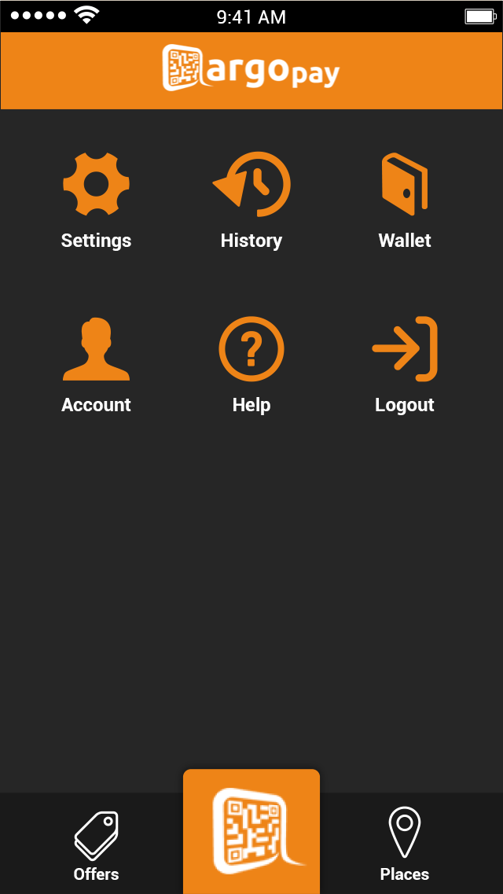

Navigation strip – icons white when not pressed

Change button arrangement: Places on left, offers on right. Scan in the middle.

* 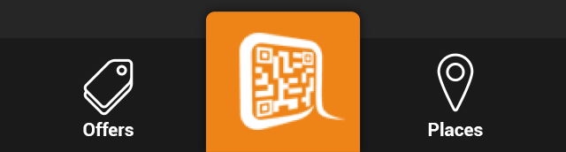
* Navigation strip – icons orange when pressed
* Change the scan icon to a downward triangle when pressed. See the Belly app behavior on the center button.
* 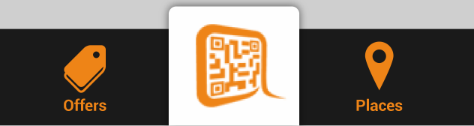
* Press any button except for offers and places before sign in will prompt sign in screen or sign up screen
* Sign up screen
* First time starting the app, give a choice of “sign up” or “sign in”.

Sign up

Sign In

Welcome to ArgoPay

No account yet?

The questions are used when you need to recover your login information. urself onlyith summary box below on current balance, pa or

* On Sign up page, remove the progress bar (step 1 of 2…)
* Required field: Email, confirm Email, Password, confirm password
* Remove “Username” field, required for ArgoCredit later
* On click validation between emails, and between password
* Place “sign in” button on top to switch to sign in screen.
* If email already used, switch to sign in screen with email pre-filled.
* 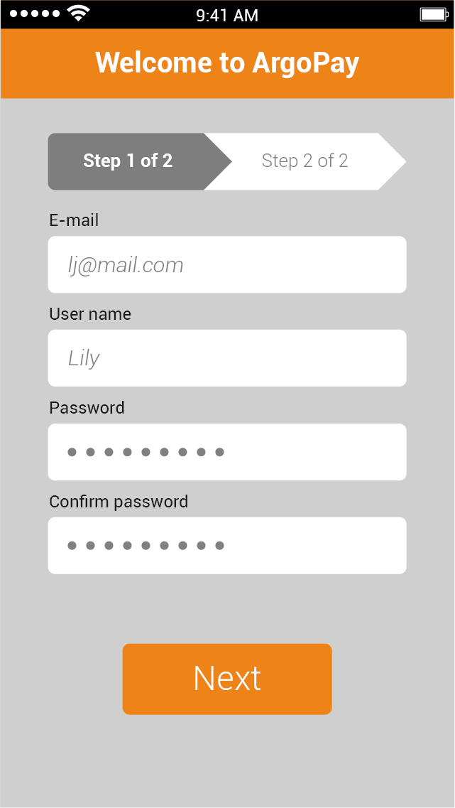
* Use “Submit” button
* 
* Upon form submission, send Email IDS-ARGO-WELCOME
* Email has link to Activate ArgoCredit ~~or Link a credit/debit card~~.
* After account registered, set up security questions.

Submit

Protect your Account

Please select 3 security questions. We will ask them when you forget your sign-in information.

Question 1 < from a drop down list>

Answer ______

Question 2 <from a drop down list>

Answer ______

Question 3 <from a drop down list>

Answer _________

The questions are used when you need to recover your login information. urself onlyith summary box below on current balance, pa

* Security questions are from 3 batches of 5 each. In recovery up to 2 of them are chosen randomly. If one answer matches, then we will allow password reset. If both answers are incorrect then user cannot recover the credential without contacting us from the help page.
* Sign In screen
* Change Username to “Username or Email”
* Username is used for ArgoCredit account holder. General user can use email.
* Orange “Submit” button
* Have a “back” button on the top left
* 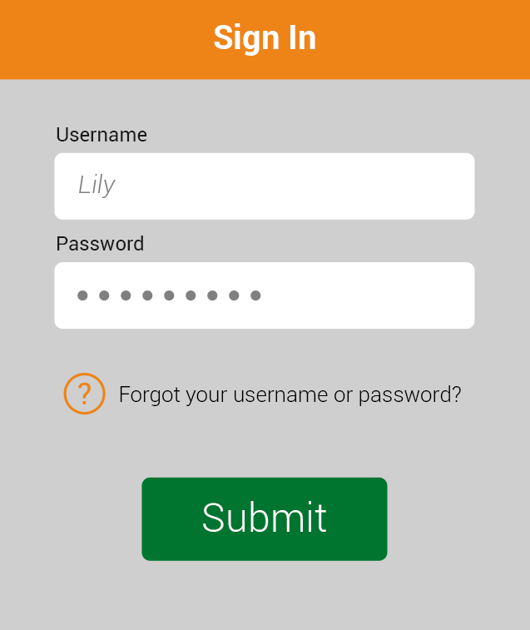
* ArgoCredit Page – Activate, Manage, View
* After sign up/sign in, if there is no payment information, user should see benefits of activating ArgoCredit.
* First time activation path
* “Benefit”

Start

Later

ArgoCredit

In 3 steps you can activate ArgoCredit account.

Convenient: It’s “credit on the go” offered by ArgoPay. No plastic to carry around.

Fast: Access through the ArgoPay app.

Convenient: View your balance instantly.

Safe: All your information is secured in the cloud.

(Link to account disclosure)

* Activation start

No

Yes

ArgoCredit activation

Are you a resident of <states we support>?

* States we support includes Massachusetts, Connecticut and New York.
* Step1: If Yes, “Personal Information”
* 1. Name, Date of Birth, Gender
* 2. Physical address: Home street address, apt/ste# (optional), home zip code. Populate city and state based on zip code.
* 3. Primary phone number (10 digit)
* 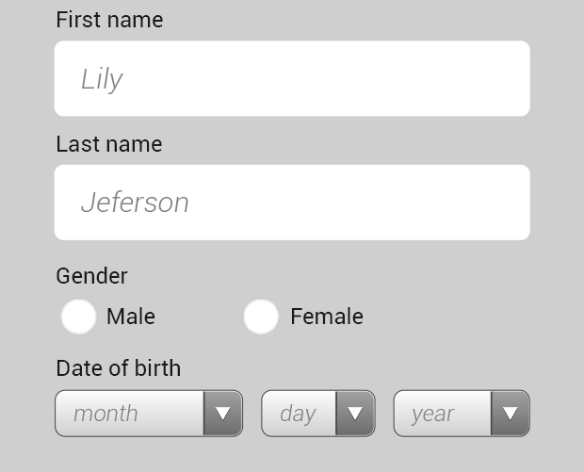

If No, screen say “ArgoCredit is coming soon”. Button to return home.

If Age is under 21, say “Currently ArgoCredit is available to person age 21 and above. We are working hard to allow you to use that later.” – Return to home.

(If Authorized user is built.. then

If Age is under 21, say “ArgoCredit is available to person age 21 and above. You can still use ArgoCredit if someone over 21 adds you as an authorized user. Do you want us to send a note to that person?” – Enter Email to send to another person.

After Email entry, say “Thank you. Your contact will receive an email about activating ArgoCredit and add you as an authorized user.” Button to return home. )

Step 2 Verify personal information.

Display text” You will be asked 4 questions about yourself. Please choose the answer that apply”

Mock up screen with IDology question shows up. If not success, then exit with message “Sorry we cannot verify your information.”

Step 2 of 3: Verification

Which street did you live in around 2009?

Birch Street

Lively Street

Center Street

Main Street

None of the above

Step 3 of 3: Additional Information

Do you have checking accounts?

Total Value of financial assets (including checking, savings, investment and other accounts)

(picker: under 5K, 5-10K, 10-25K, 25K+)

Income Source

(picker: employed, unemployed, self-employed, student-employed, student-unemployed)

Annual Income level (picker: under 10K, 10-25K, 25-50K, 50-75K, 75-100K, 100k+)

Congratulations! You ArgoCredit account is activated Credit limit

$100

* You can use ArgoCredit at all businesses accepting ArgoPay.

Terms and Conditions (Link to member agreement, E-sign disclosure, Privacy notice)

These steps are removed from the activation flow.

(optional; not live in version 1)

Authorized User

End

Add more

Authorized User Name:_______

Authorized User Email:________

* Places Listing
* Add a “map view” button on top right
* Title should be “Places”
* Remove the line “Current Businesses”
* Bottom navigation: Places on left, offers on right.
* 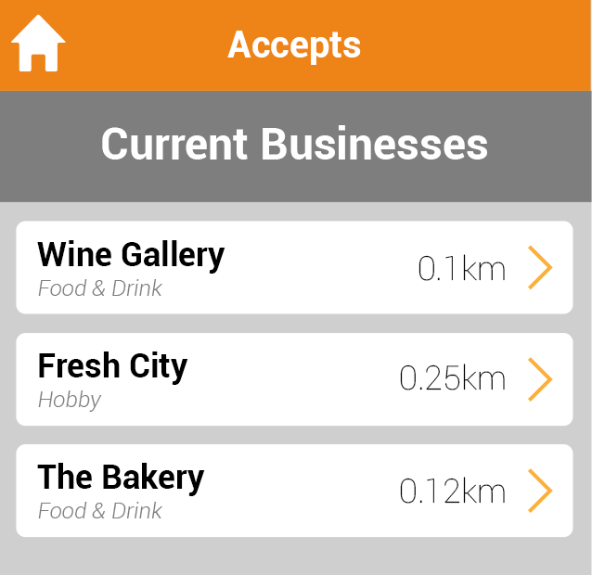
* Place detail
* Change the home button to back button
* Click “Redeem” button brings up a pop up box –
* “Do you want to redeem X points to Y credit”, two options: Yes, Cancel.
* Once a credit is redeemed, the button changes to “Manage” , click the Manage button will direct user to rewards screen.
* 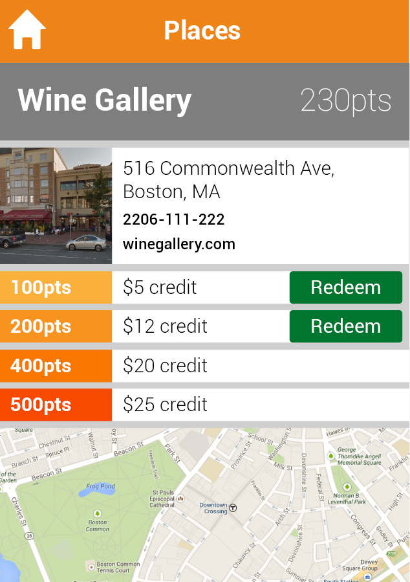
* Scan QR code by pressing the “Scan” button, the button changes to down arrow at the scan screen
* 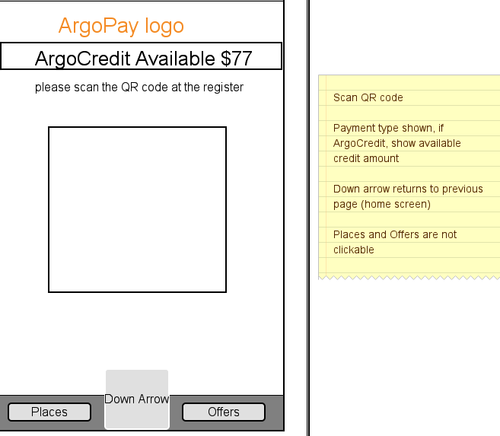
* Confirm transaction if transaction is found
* 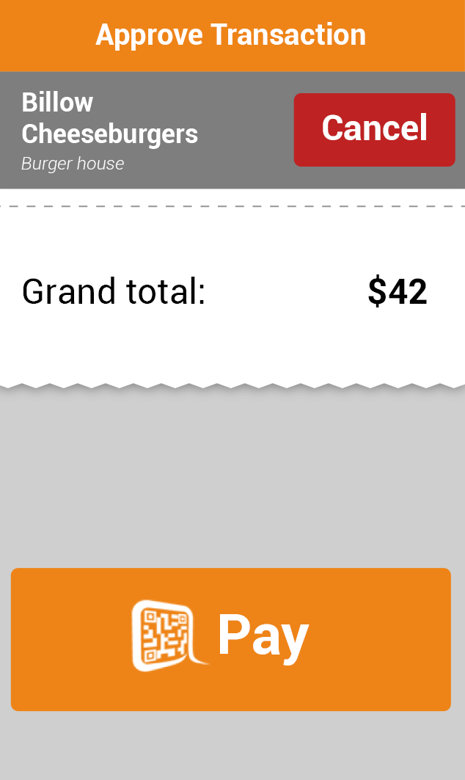
* Error page if press the “cancel” page.
* Error message are configurable
* “You have cancelled the transaction”.
* Other possible error message
* “No wireless or data connection”
* “Transaction cannot be found”.
* 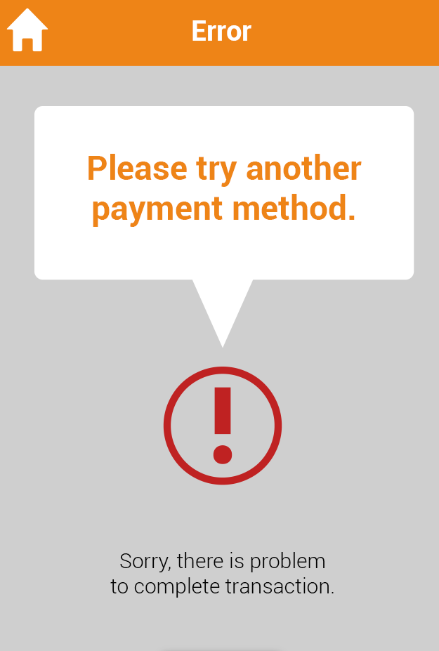
* Help screen
* 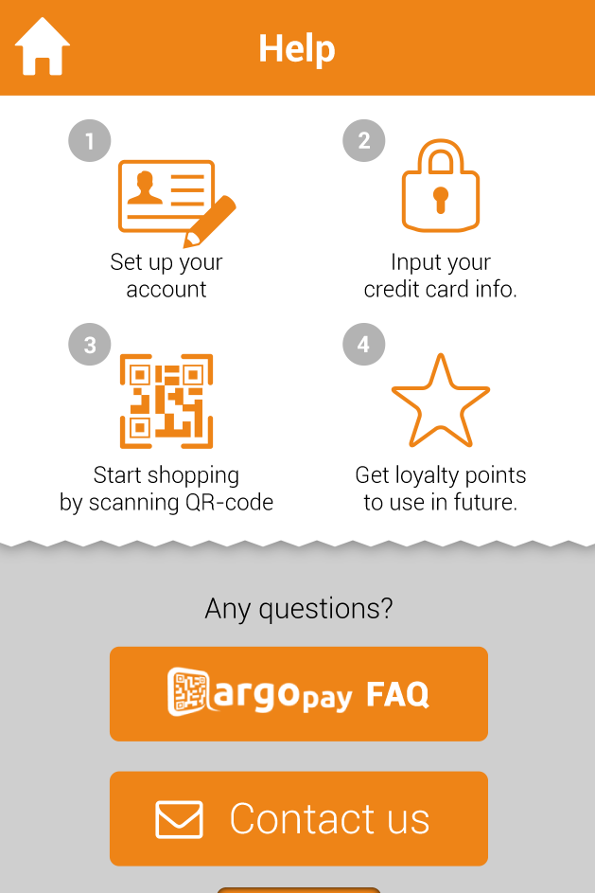
* ArgoPay FAQ page should show list of questions, and click each one will get to expanded answer page.
* Contact us link just prompt user to send a email to [support@argopay.com](mailto:support@argopay.com) using local email client.
* Send automated email after the message is received
* IDS – Email - ContactUsEmailReceipt
* Offers screen show all active offers from merchant, selected offers will have a check mark next to it.
* Sort by: Newest, ready to use (selected), available to select, expiring soon, recommended for you
* 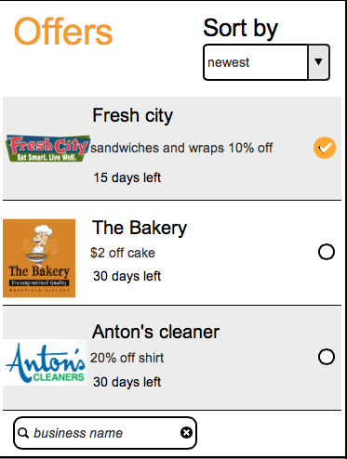
* Offer detail
* Click the offer link brings up the offer detail screen and select the offer
* Offer detail includes merchant name, address.
* 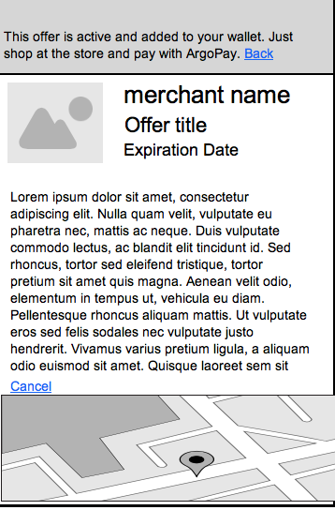
* Rewards screen
* List rewards from all merchants. Potentially limit to merchant in certain city/geographic area.
* Rewards sortable by point value, ready to use (already redeemed), available to me (can be redeemed)
* Click merchant name directs to place detail screen, showing rewards for that merchant
* Points: List points required for redemption of specific credit. Points are combined merchant loyalty points and global points (earned from using ArgoCredit).
* When the user clicks “redeem”, the points are deducted first from Merchant Specific loyalty point balance, and then deducted from global points. Users cannot choose which point balance to apply first.
* Credit will be applied to next purchase at the merchant automatically. If a credit is not fully used, credit balance should still show, but point value should not show.
* 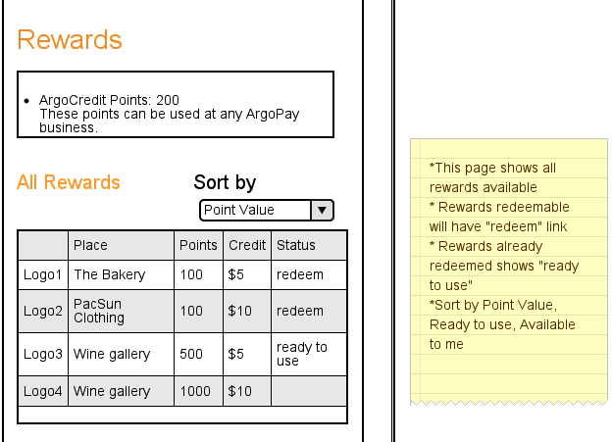
* Return any purchase previous paid by credits will result in credit return to “rewards”.
* AgroCredit Account Management
* “Quick View” screen
* 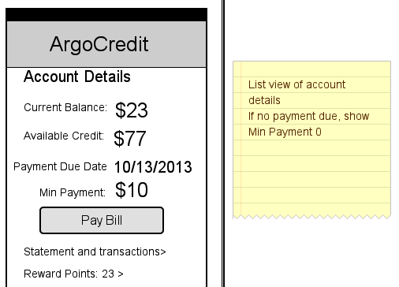
* “Statement and Transactions” screen
* Toggle between show recent transactions and transactions in a statement cycle.
* For statement view,
* Allow user to choose current statement and last 4 month statement
* display a link in the bottom to get PDF statement, or email PDF statement to user.
* 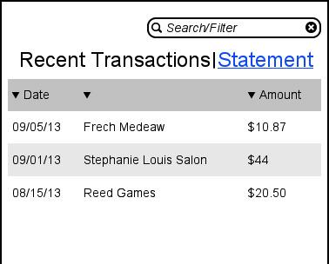
* Search/Filter screen
* Search is for business name field only
* Filter by Date range, default is current statement cycle, allow searching transactions in last 4 statement cycles (120 days)
* 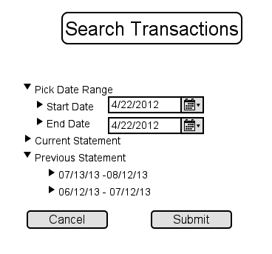
* Search result display
* Transactions
* <start dete>-<end date>
* Showing X results for <search term>
* Date, Description, Amount in table form
* If search returns nothing, display
* Transactions
* <start date>-<end date>
* There is no transaction meeting your criteria.
* Dispute a transaction
* For the launch, if a user needs to dispute a transaction, they will use a link on the button of transaction list, and the link asks them to send email to argopay.
* After receiving the email, send automatic response
* IDS-Email-ContactUsEmailReceipt
* Statement view is the same as transaction view, just limit the date range to current statement. In the bottom of statement view, there is a link to points statement.
* 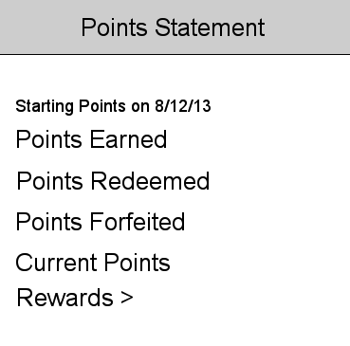
* Pay Bill
* Click “Pay bill” will allow user to schedule a payment
* Payment date should be between today (if before 5PM) and the payment due date. If today time is after 5PM EST then today option is greyed out.
* Add bank information.
* If there is not any bank information added yet, user will see this screen to add bank info.

Bank Information

Bank Routing Number _________(Number)

Bank Name _________(Free text)

Checking Account Number ___________(Number)

* After bank information entered – Verify Bank account information via ACH and send confirmation Email.
* IDS-Email-BankInfoConfirm
* If bank account cannot be verified, Email user to update bank information and re-verify.
* IDS-Email-BankInfoError
* If the verification failed again, resend update bank information email.
* Resend the email after 2 days if the bank information is not updated..
* 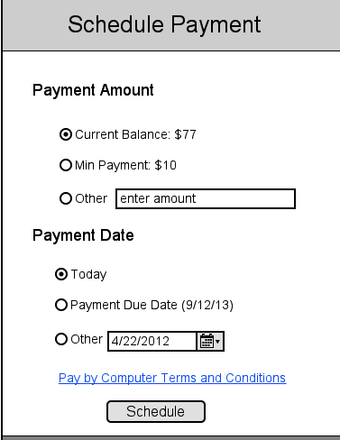

Bank Information

* Click Schedule to get confirmation screen, with link to payment history.
* 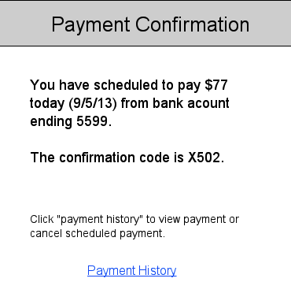
* Payment history allows user to cancel pending payment
* 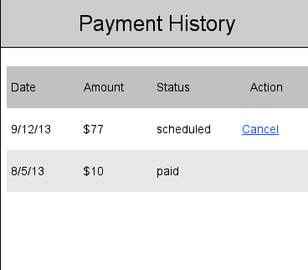
* We will suspend the account after due date if payment is not scheduled or paid.
* IDS-Email-AcctSupspended
* Click Point balance directs to Rewards screen.
* History displays all transactions up to X days (180 days or whatever we can handle). Refund request will need to started here.
* 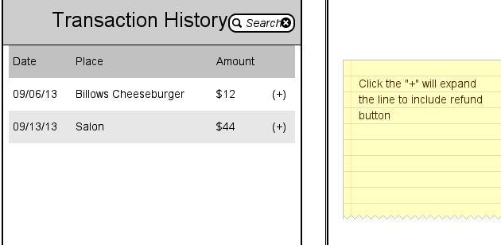
* Settings
* A list format mainly have text
* List of items under settings:
* 1. PIN two subsections > Enable PIN lock > Reset PIN (4 digit)
* 2. Account Information (Edit Email address, phone number, address update) requires password
* 3. Reset Password – requires password
* 4. Notification setting - allow push notifications, notify me when XX happens (require more definition)